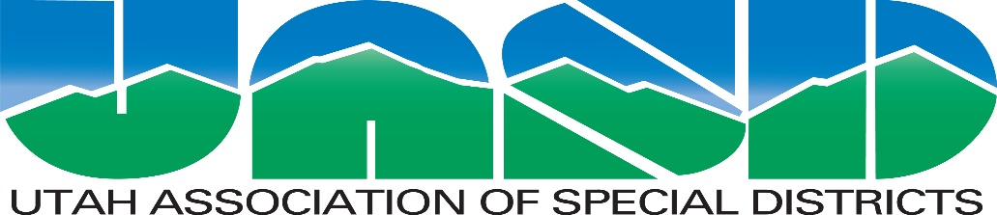

Surplus Property Policy Template
Prepared for
The adoption and use of Special and Special Service Districts
in Utah in consultation with their legal counsel

Prepared by
The Utah Association of Special Districts
November 9, 2023 Update
___________________________________________________
(insert the District’s name)

SURPLUS PROPERTY POLICY

- Disposal of Surplus Property:

  - Report: Surplus District property is to be disposed of in a manner that is in the best interest of the District. Excepting property having a de minimis value, all surplus property shall be reported to the governing body (the “Board”) of _______________________________ (the “District”) including, after disposal of the surplus property, a report describing the property, whether the property has been or will be replaced, and the consideration received for the property by the District.

  - Authorization: The designated Procurement Official is authorized to dispose of District surplus property the salvage value of which does not exceed $_______ that will not be required for future District use. The disposal of surplus property having a value in excess of the designated threshold requires prior Board authorization. Surplus property is to be disposed of in a commercially reasonable manner as the designated Procurement Official or the Board, should the Board so elect, sees fit, with all net proceeds of the disposal to be the property of the District.

  - Disposal Service: Surplus property may be delivered, for disposal, to a reputable online auction or other disposal service at the discretion of the designated Procurement Official or as directed by the Board.

  - Employee Purchases: Surplus property which is sold through a public auction may be purchased by a District employee.

  - Trade In: The foregoing shall not apply when the surplus property, such as a vehicle or equipment, is being “traded in” on the purchase of substitute property in conformance with the requirements of the procurement laws and rules that are applicable to the District.

  - Local Government Preference: Local units of government, such as a municipality, special district, special service district, county or school district located in the same county as the District; or a Utah municipality, special district, special service district, county or school district located in a different county; may be (but are not required to be) given a preference in the acquisition of the District’s surplus property.

- Salvage: Metal and other items of some residual value may be salvaged by employees of the District while working on District facilities and improvements. Such salvaged items continue to be the property of the District and are to be disposed of accordingly. As a consequence, all receipts from salvaging such items shall be the property of the District and shall be safeguarded and accounted for as such.

- Donation, Disposal, or Destruction of Surplus Property: The designated Procurement Official may donate to a governmental or charitable organization, destroy, or dispose of as waste any surplus property that is estimated in good faith to be worth less than $_______ without involvement of the Board, and may dispose of property having an estimated value in excess of the designated threshold with Board approval if:

  - The surplus property fails to sell at auction;

  - The cost of selling the surplus property is greater than or equal to the value of the surplus property;

  - The surplus property is no longer usable;

  - The surplus property is damaged and either cannot be repaired or the cost of repair is greater than or equal to the value of the surplus property in a repaired state; or

  - The surplus property can be replaced for less than the cost of repairing the surplus property.

- Sale of Previously Purchased Procurement Item: Should surplus property be sold to a person from whom the District originally acquired the property (a “buyback purchaser”), Utah Code Ann. § 63G-6a-117, part of the Utah Procurement Code, will apply. If the District sells property to a buyback purchaser for an amount in excess of the amount the District paid for the property, the District shall:

  - Require the buyback purchaser to pay cash for the item;

  - Not accept the excess repurchase amount in the form of a credit, discount or other incentive on a future purchase that the District may make from the buyback purchaser; and

  - Not use the excess repurchase amount to acquire an additional procurement item from the buyback purchaser.

- Removal of Useful Components: Ancillary or component parts or equipment may be removed from vehicles, trailers or equipment that is/are intended to be sold as surplus and be retained for further use by the District or by another local government located in the state of Utah pursuant to A.6. above.

- Surplus Electronic Data Devices: Before an electronic data device is transferred or otherwise disposed of:

  - Any software owned or licensed by the District shall be removed as required by the applicable software license agreement;

  - Information that is classified as protected, private or controlled under the Government Records Access and Management Act, Title 63G, Chapter 2 of the Utah Code, will also be removed, as will other district-owned records and data;

  - Steps will be taken to ensure that the service contract for the device is null and void or is transferrable to the new owner of the device; and

  - If the device is not transferred to a new owner, the foregoing steps will be completed or the device will be destroyed in such a manner as to guarantee that information and data cannot be retrieved from the device.

Approved by the governing body of the District on the ___ day of ___________________, 20____.

Title: _________________________

4857-9651-8285, v. 1

Not to be used if the District has a Procurement Policy that includes a policy regarding the disposal of surplus property.
Until this blank is filled in, the threshold will be $2,000.
Until this blank is filled in with a different dollar value, the threshold will be $100.00.

